**TASK 1.2 SQL ORACLE**

**Stage 1:**

1. **Construct and ER-Diagram for the above-mentioned Requirement**

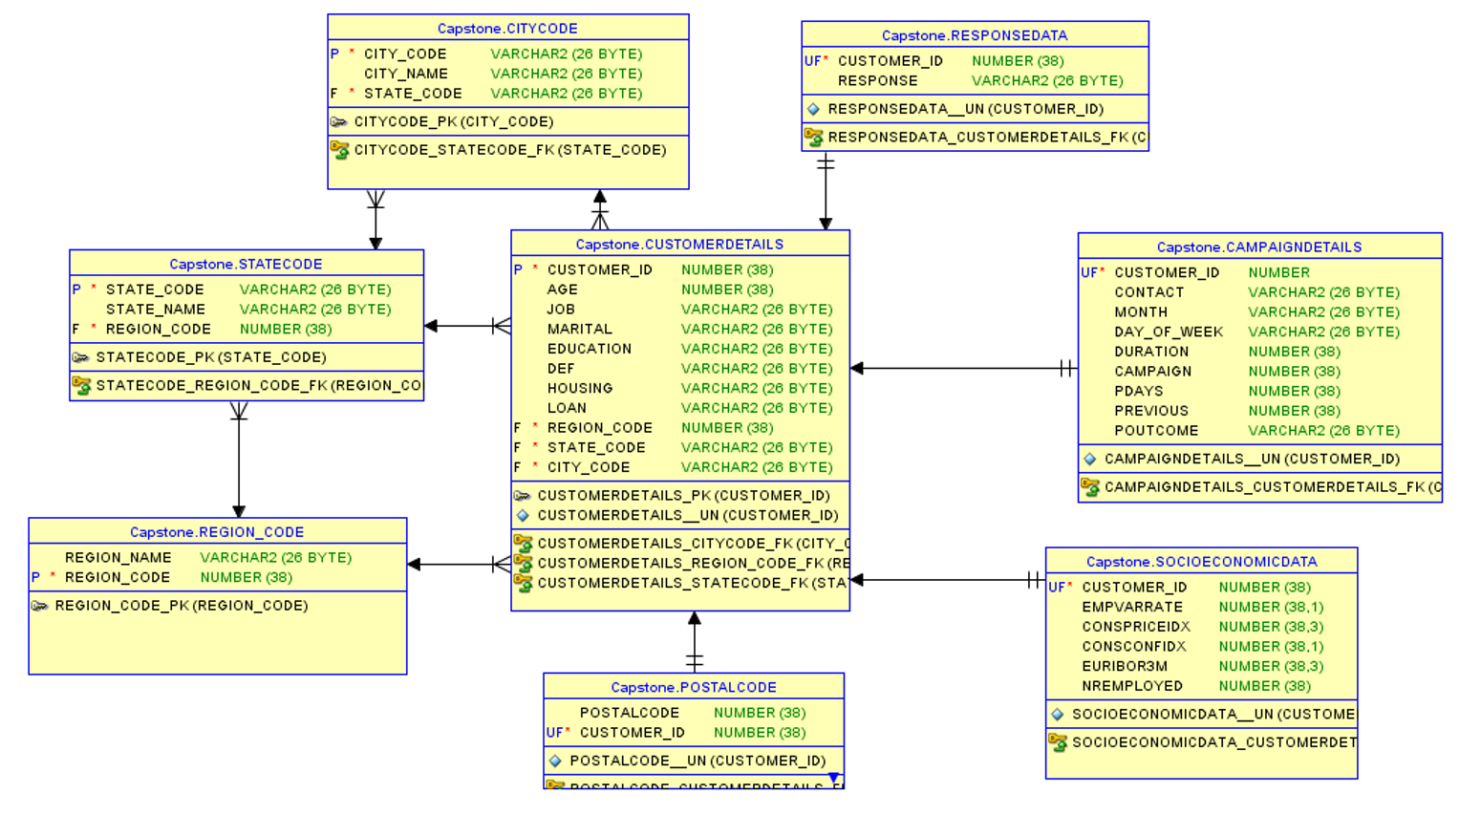

Fig: Entity Relationship Diagram

1. **Construct Tables has per the ER-Diagram.**

CREATE TABLE campaigndetails (

customer_id NUMBER(38) NOT NULL,

contact VARCHAR2(26 BYTE),

month VARCHAR2(26 BYTE),

day_of_week VARCHAR2(26 BYTE),

duration NUMBER(38),

campaign NUMBER(38),

pdays NUMBER(38),

previous NUMBER(38),

poutcome VARCHAR2(26 BYTE)

)

CREATE TABLE citycode (

city_code VARCHAR2(26 BYTE) NOT NULL,

city_name VARCHAR2(26 BYTE),

state_code VARCHAR2(26 BYTE)

)

CREATE TABLE customerdetails (

customer_id NUMBER(38) NOT NULL,

age NUMBER(38),

job VARCHAR2(26 BYTE),

marital VARCHAR2(26 BYTE),

education VARCHAR2(26 BYTE),

def VARCHAR2(26 BYTE),

housing VARCHAR2(26 BYTE),

loan VARCHAR2(26 BYTE),

region_code VARCHAR2(26 BYTE),

state_code VARCHAR2(26 BYTE),

city_code VARCHAR2(26 BYTE)

)

CREATE TABLE postalcode (

postalcode NUMBER(38),

customer_id NUMBER(38) NOT NULL

)

CREATE TABLE region_code (

region_name VARCHAR2(26 BYTE),

region_code NUMBER(38) NOT NULL

)

CREATE TABLE responsedata (

customer_id NUMBER(38) NOT NULL,

response VARCHAR2(26 BYTE)

)

CREATE TABLE socioeconomicdata (

customer_id NUMBER(38) NOT NULL,

empvarrate NUMBER(38, 1),

conspriceidx NUMBER(38, 3),

consconfidx NUMBER(38, 1),

euribor3m NUMBER(38, 3),

nremployed NUMBER(38)

)

CREATE TABLE statecode (

state_code VARCHAR2(26 BYTE) NOT NULL,

state_name VARCHAR2(26 BYTE),

region_code NUMBER(38)

)

1. **Identify the relationships between tables and use appropriate standards for the same where applicable**

The "customerdetails" has **"Many to One"** relationship with "citycode”, "statecode" and "regioncode" tables.

The "responsedata”, "campaigndetails”, "socioeconomicdata" and "postalcode" tables have **"One and Only One"** relationship with the "customerdetails" table.

**Stage 2:**

1. **Generate the list of customer has per age and profession and display them according to ascending order of the age.**

select AGE,JOB from CUSTOMERDETAILS order by AGE;

**OUTPUT:**

1. **Generate the list of customer who have no housing loan and personal loan.**

select customer_id from CUSTOMERDETAILS where housing='no' and loan='no';

**OUTPUT:**

1. **Generate the list of customers who has credit and has been contacted more than 2 times during the campaign.**

select cb.customer_id,cb.default1,cp.campaign

from CUSTOMERDETAILS cb join CAMPAIGNDETAILS cp

ON cb.customer_id = cp.customer_ID

where cp.campaign>2

**OUTPUT:**

1. **Generate the list of customer who has credit and has been contacted more than 2 times during the campaign and outcome of the campaign is successful.**

select cb.customer_id,cb.default1,cp.campaign

from CUSTOMERDETAILS cb join CAMPAIGNDETAILS cp

ON cb.CUSTOMER_ID = cp.CUSTOMER_ID where cp.campaign>2

AND cb.default1 like 'yes' and cp.poutcome='success';

**OUTPUT:**

1. **Generate the list of customers who has credit and has been contacted more than 2 times during the campaign and outcome of the campaign is failure and who have been contacted in the month of June and also display the day contacted.**

select cb.customer_id,cb.default1,cp.campaign

from CUSTOMERDETAILS cb join CAMPAIGNDETAILS cp

ON cb.CUSTOMER_ID = cp.CUSTOMER_ID

where cp.campaign>2

and cp.poutcome='success'and cp.month = 'jun';

**OUTPUT:**

1. **Generate report giving state-wise breakup of number of customers.**

select st.state_name,count(customer_id) as numberofCustomers

from CUSTOMERDETAILS cust inner join STATECODE st on cust.state_code=st.state_code

group by st.state_name;

**OUTPUT:**

1. **Generate report giving city-wise distribution of customers**

select st.city_name,count(customer_id) as numberofCustomers

from CUSTOMERDETAILS cust inner join CITYCODE st on cust.city_code=st.city_code

group by st.city_name;

**OUTPUT:**

